Graph

A graph can be defined as group of vertices and edges that are used to connect these vertices. A graph can be seen as a cyclic tree, where the vertices (Nodes) maintain any complex relationship among them instead of having parent child relationship.

Definition

A graph G can be defined as an ordered set G(V, E) where V(G) represents the set of vertices and E(G) represents the set of edges which are used to connect these vertices.

A Graph G(V, E) with 5 vertices (A, B, C, D, E) and six edges ((A,B), (B,C), (C,E), (E,D), (D,B), (D,A)) is shown in the following figure.

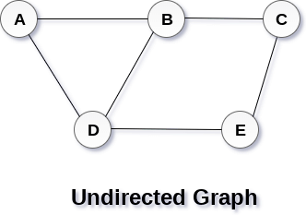

## Directed and Undirected Graph

A graph can be directed or undirected. However, in an undirected graph, edges are not associated with the directions with them. An undirected graph is shown in the above figure since its edges are not attached with any of the directions. If an edge exists between vertex A and B then the vertices can be traversed from B to A as well as A to B.

In a directed graph, edges form an ordered pair. Edges represent a specific path from some vertex A to another vertex B. Node A is called initial node while node B is called terminal node.

A directed graph is shown in the following figure.

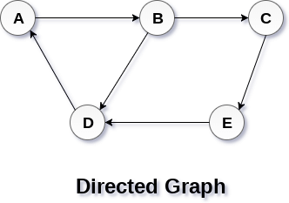

## Graph Terminology

### **Path**

A path can be defined as the sequence of nodes that are followed in order to reach some terminal node V from the initial node U.

### **Closed Path**

A path will be called as closed path if the initial node is same as terminal node. A path will be closed path if V0=VN.

### **Simple Path**

If all the nodes of the graph are distinct with an exception V0=VN, then such path P is called as closed simple path.

### **Cycle**

A cycle can be defined as the path which has no repeated edges or vertices except the first and last vertices.

### **Connected Graph**

A connected graph is the one in which some path exists between every two vertices (u, v) in V. There are no isolated nodes in connected graph.

### **Complete Graph**

A complete graph is the one in which every node is connected with all other nodes. A complete graph contain n(n-1)/2 edges where n is the number of nodes in the graph.

### **Weighted Graph**

In a weighted graph, each edge is assigned with some data such as length or weight. The weight of an edge e can be given as w(e) which must be a positive (+) value indicating the cost of traversing the edge.

### **Digraph**

A digraph is a directed graph in which each edge of the graph is associated with some direction and the traversing can be done only in the specified direction.

### **Loop**

An edge that is associated with the similar end points can be called as Loop.

### **Adjacent Nodes**

If two nodes u and v are connected via an edge e, then the nodes u and v are called as neighbours or adjacent nodes.

### **Degree of the Node**

A degree of a node is the number of edges that are connected with that node. A node with degree 0 is called as isolated node.

# Graph Representation

By Graph representation, we simply mean the technique which is to be used in order to store some graph into the computer's memory.

There are two ways to store Graph into the computer's memory. In this part of this tutorial, we discuss each one of them in detail.

## 1. Sequential Representation

In sequential representation, we use adjacency matrix to store the mapping represented by vertices and edges. In adjacency matrix, the rows and columns are represented by the graph vertices. A graph having n vertices, will have a dimension **n x n**.

An entry Mij in the adjacency matrix representation of an undirected graph G will be 1 if there exists an edge between Vi and Vj.

An undirected graph and its adjacency matrix representation is shown in the following figure.

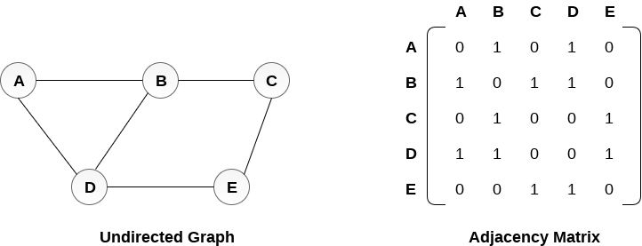

in the above figure, we can see the mapping among the vertices (A, B, C, D, E) is represented by using the adjacency matrix which is also shown in the figure.

There exists different adjacency matrices for the directed and undirected graph. In directed graph, an entry Aij will be 1 only when there is an edge directed from Vi to Vj.

A directed graph and its adjacency matrix representation is shown in the following figure.

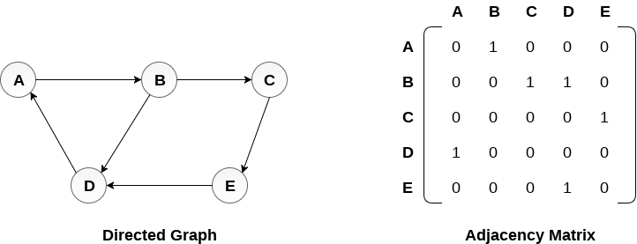

Representation of weighted directed graph is different. Instead of filling the entry by 1, the Non- zero entries of the adjacency matrix are represented by the weight of respective edges.

The weighted directed graph along with the adjacency matrix representation is shown in the following figure.

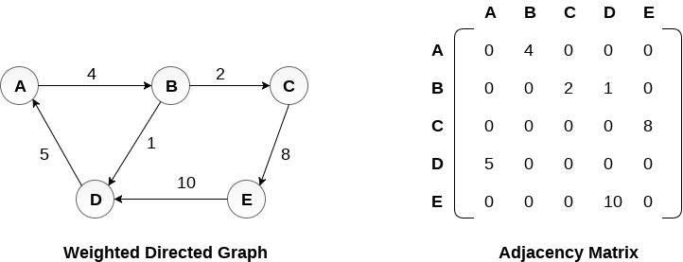

Linked Representation

In the linked representation, an adjacency list is used to store the Graph into the computer's memory.

Consider the undirected graph shown in the following figure and check the adjacency list representation.

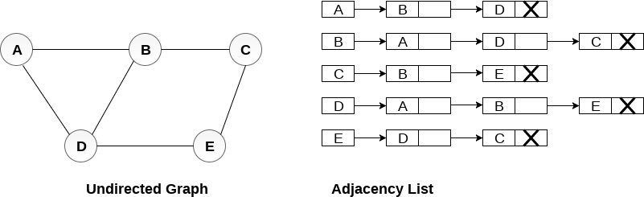

An adjacency list is maintained for each node present in the graph which stores the node value and a pointer to the next adjacent node to the respective node. If all the adjacent nodes are traversed then store the NULL in the pointer field of last node of the list. The sum of the lengths of adjacency lists is equal to the twice of the number of edges present in an undirected graph.

Consider the directed graph shown in the following figure and check the adjacency list representation of the graph.

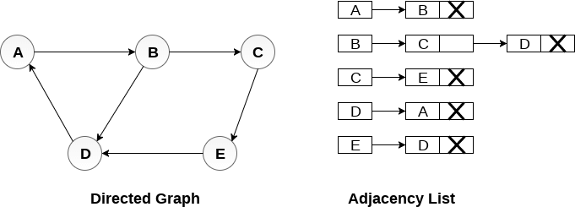

In a directed graph, the sum of lengths of all the adjacency lists is equal to the number of edges present in the graph.

In the case of weighted directed graph, each node contains an extra field that is called the weight of the node. The adjacency list representation of a directed graph is shown in the following figure.

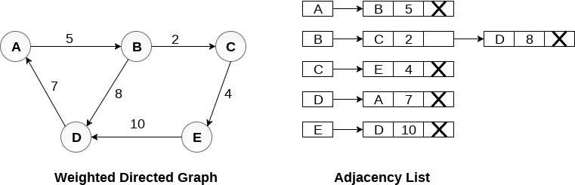

# Graph Traversal Algorithm

In this part of the tutorial we will discuss the techniques by using which, we can traverse all the vertices of the graph.

Traversing the graph means examining all the nodes and vertices of the graph. There are two standard methods by using which, we can traverse the graphs. Lets discuss each one of them in detail.

* Breadth First Search
* Depth First Search

## Breadth First Search (BFS) Algorithm

Breadth first search is a graph traversal algorithm that starts traversing the graph from root node and explores all the neighbouring nodes. Then, it selects the nearest node and explore all the unexplored nodes. The algorithm follows the same process for each of the nearest node until it finds the goal.

The algorithm of breadth first search is given below. The algorithm starts with examining the node A and all of its neighbours. In the next step, the neighbours of the nearest node of A are explored and process continues in the further steps. The algorithm explores all neighbours of all the nodes and ensures that each node is visited exactly once and no node is visited twice.

## Algorithm

* **Step 1:** SET STATUS = 1 (ready state)  
  for each node in G
* **Step 2:** Enqueue the starting node A  
  and set its STATUS = 2  
  (waiting state)
* **Step 3:** Repeat Steps 4 and 5 until  
  QUEUE is empty
* **Step 4:** Dequeue a node N. Process it  
  and set its STATUS = 3  
  (processed state).
* **Step 5:** Enqueue all the neighbours of  
  N that are in the ready state  
  (whose STATUS = 1) and set  
  their STATUS = 2  
  (waiting state)  
  [END OF LOOP]
* **Step 6:** EXIT

### **Example**

Consider the graph G shown in the following image, calculate the minimum path p from node A to node E. Given that each edge has a length of 1.

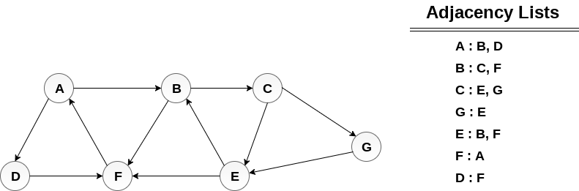

## Solution:

Minimum Path P can be found by applying breadth first search algorithm that will begin at node A and will end at E. the algorithm uses two queues, namely **QUEUE1** and **QUEUE2**. **QUEUE1** holds all the nodes that are to be processed while **QUEUE2** holds all the nodes that are processed and deleted from **QUEUE1**.

**Lets start examining the graph from Node A.**

1. Add A to QUEUE1 and NULL to QUEUE2.

1. QUEUE1 = {A}
2. QUEUE2 = {NULL}

2. Delete the Node A from QUEUE1 and insert all its neighbours. Insert Node A into QUEUE2

1. QUEUE1 = {B, D}
2. QUEUE2 = {A}

3. Delete the node B from QUEUE1 and insert all its neighbours. Insert node B into QUEUE2.

1. QUEUE1 = {D, C, F}
2. QUEUE2 = {A, B}

4. Delete the node D from QUEUE1 and insert all its neighbours. Since F is the only neighbour of it which has been inserted, we will not insert it again. Insert node D into QUEUE2.

1. QUEUE1 = {C, F}
2. QUEUE2 = { A, B, D}

5. Delete the node C from QUEUE1 and insert all its neighbours. Add node C to QUEUE2.

1. QUEUE1 = {F, E, G}
2. QUEUE2 = {A, B, D, C}

6. Remove F from QUEUE1 and add all its neighbours. Since all of its neighbours has already been added, we will not add them again. Add node F to QUEUE2.

1. QUEUE1 = {E, G}
2. QUEUE2 = {A, B, D, C, F}

7. Remove E from QUEUE1, all of E's neighbours has already been added to QUEUE1 therefore we will not add them again. All the nodes are visited and the target node i.e. E is encountered into QUEUE2.

1. QUEUE1 = {G}
2. QUEUE2 = {A, B, D, C, F,  E}

Now, backtrack from E to A, using the nodes available in QUEUE2.

The minimum path will be **A → B → C → E**.

# Depth First Search (DFS) Algorithm

Depth first search (DFS) algorithm starts with the initial node of the graph G, and then goes to deeper and deeper until we find the goal node or the node which has no children. The algorithm, then backtracks from the dead end towards the most recent node that is yet to be completely unexplored.

The data structure which is being used in DFS is stack. The process is similar to BFS algorithm. In DFS, the edges that leads to an unvisited node are called discovery edges while the edges that leads to an already visited node are called block edges.

## Algorithm

* **Step 1:** SET STATUS = 1 (ready state) for each node in G
* **Step 2:** Push the starting node A on the stack and set its STATUS = 2 (waiting state)
* **Step 3:** Repeat Steps 4 and 5 until STACK is empty
* **Step 4:** Pop the top node N. Process it and set its STATUS = 3 (processed state)
* **Step 5:** Push on the stack all the neighbours of N that are in the ready state (whose STATUS = 1) and set their  
  STATUS = 2 (waiting state)  
  [END OF LOOP]
* **Step 6:** EXIT

### **Example :**

Consider the graph G along with its adjacency list, given in the figure below. Calculate the order to print all the nodes of the graph starting from node H, by using depth first search (DFS) algorithm.

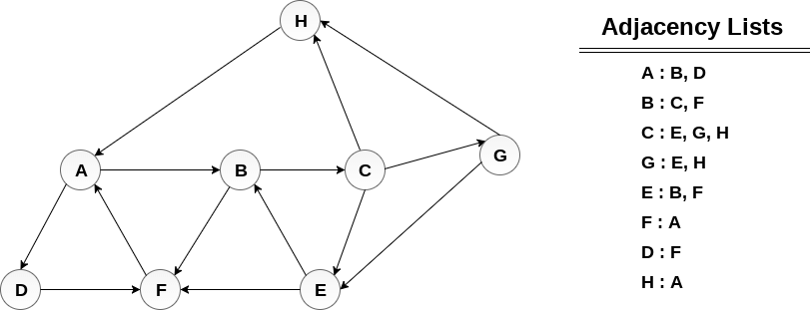

### **Solution :**

Push H onto the stack

1. STACK : H

POP the top element of the stack i.e. H, print it and push all the neighbours of H onto the stack that are is ready state.

1. Print H
2. STACK : A

Pop the top element of the stack i.e. A, print it and push all the neighbours of A onto the stack that are in ready state.

1. Print A
2. Stack : B, D

Pop the top element of the stack i.e. D, print it and push all the neighbours of D onto the stack that are in ready state.

1. Print D
2. Stack : B, F

Pop the top element of the stack i.e. F, print it and push all the neighbours of F onto the stack that are in ready state.

1. Print F
2. Stack : B

Pop the top of the stack i.e. B and push all the neighbours

1. Print B
2. Stack : C

Pop the top of the stack i.e. C and push all the neighbours.

1. Print C
2. Stack : E, G

Pop the top of the stack i.e. G and push all its neighbours.

1. Print G
2. Stack : E

Pop the top of the stack i.e. E and push all its neighbours.

1. Print E
2. Stack :

Hence, the stack now becomes empty and all the nodes of the graph have been traversed.

The printing sequence of the graph will be :

1. H → A → D → F → B → C → G → E

# Spanning Tree

Spanning tree can be defined as a sub-graph of connected, undirected graph G that is a tree produced by removing the desired number of edges from a graph. In other words, Spanning tree is a non-cyclic sub-graph of a connected and undirected graph G that connects all the vertices together. A graph G can have multiple spanning trees.

## Minimum Spanning Tree

There can be weights assigned to every edge in a weighted graph. However, A minimum spanning tree is a spanning tree which has minimal total weight. In other words, minimum spanning tree is the one which contains the least weight among all other spanning tree of some particular graph.

## Shortest path algorithms

In this section of the tutorial, we will discuss the algorithms to calculate the shortest path between two nodes in a graph.

# Prim's Algorithm

Prim's Algorithm is used to find the minimum spanning tree from a graph. Prim's algorithm finds the subset of edges that includes every vertex of the graph such that the sum of the weights of the edges can be minimized.

Prim's algorithm starts with the single node and explore all the adjacent nodes with all the connecting edges at every step. The edges with the minimal weights causing no cycles in the graph got selected.

The algorithm is given as follows.

## Algorithm

* **Step 1:** Select a starting vertex
* **Step 2:** Repeat Steps 3 and 4 until there are fringe vertices
* **Step 3:** Select an edge e connecting the tree vertex and fringe vertex that has minimum weight
* **Step 4:** Add the selected edge and the vertex to the minimum spanning tree T  
  [END OF LOOP]
* **Step 5:** EXIT

### **Example :**

Construct a minimum spanning tree of the graph given in the following figure by using prim's algorithm.

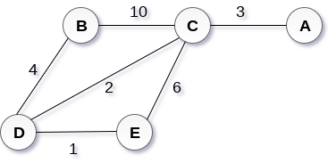

## Solution

* **Step 1 :** Choose a starting vertex B.
* **Step 2:** Add the vertices that are adjacent to A. the edges that connecting the vertices are shown by dotted lines.
* **Step 3:** Choose the edge with the minimum weight among all. i.e. BD and add it to MST. Add the adjacent vertices of D i.e. C and E.
* **Step 3:** Choose the edge with the minimum weight among all. In this case, the edges DE and CD are such edges. Add them to MST and explore the adjacent of C i.e. E and A.
* **Step 4:** Choose the edge with the minimum weight i.e. CA. We can't choose CE as it would cause cycle in the graph.

The graph produces in the step 4 is the minimum spanning tree of the graph shown in the above figure.

The cost of MST will be calculated as;

cost(MST) = 4 + 2 + 1 + 3 = 10 units.

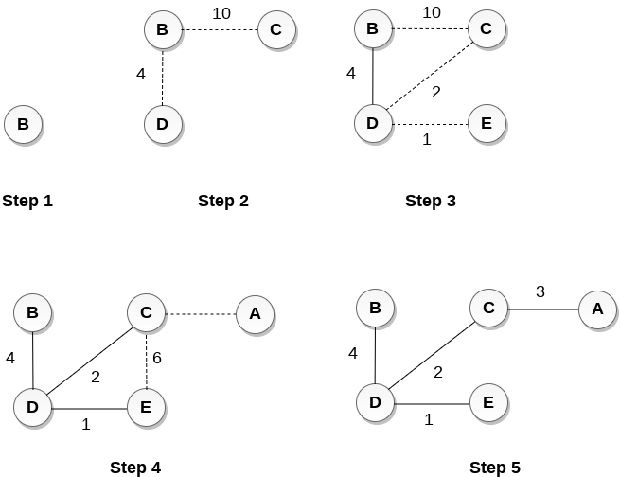

# Kruskal's Algorithm

Kruskal's Algorithm is used to find the minimum spanning tree for a connected weighted graph. The main target of the algorithm is to find the subset of edges by using which, we can traverse every vertex of the graph. Kruskal's algorithm follows greedy approach which finds an optimum solution at every stage instead of focusing on a global optimum.

The Kruskal's algorithm is given as follows.

## Algorithm

* **Step 1:** Create a forest in such a way that each graph is a separate tree.
* **Step 2:** Create a priority queue Q that contains all the edges of the graph.
* **Step 3:** Repeat Steps 4 and 5 while Q is NOT EMPTY
* **Step 4:** Remove an edge from Q
* **Step 5:** IF the edge obtained in Step 4 connects two different trees, then Add it to the forest (for combining two trees into one tree).  
  ELSE  
  Discard the edge
* **Step 6:** END

### **Example :**

**Apply the Kruskal's algorithm on the graph given as follows.**

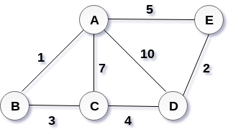

## Solution:

the weight of the edges given as :

|  |  |  |  |  |  |  |  |
| --- | --- | --- | --- | --- | --- | --- | --- |
| **Edge** | **AE** | **AD** | **AC** | **AB** | **BC** | **CD** | **DE** |
| Weight | 5 | 10 | 7 | 1 | 3 | 4 | 2 |

Sort the edges according to their weights.

|  |  |  |  |  |  |  |  |
| --- | --- | --- | --- | --- | --- | --- | --- |
| **Edge** | **AB** | **DE** | **BC** | **CD** | **AE** | **AC** | **AD** |
| Weight | 1 | 2 | 3 | 4 | 5 | 7 | 10 |

Start constructing the tree;

Add AB to the MST;

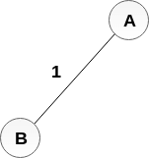

Add DE to the MST;

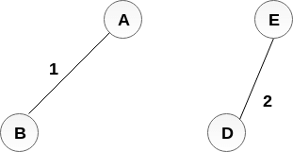

Add BC to the MST;

  
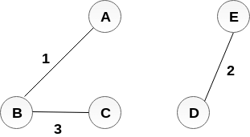

The next step is to add AE, but we can't add that as it will cause a cycle.

The next edge to be added is AC, but it can't be added as it will cause a cycle.

The next edge to be added is AD, but it can't be added as it will contain a cycle.

Hence, the final MST is the one which is shown in the step 4.

the cost of MST = 1 + 2 + 3 + 4 = 10.